Review:

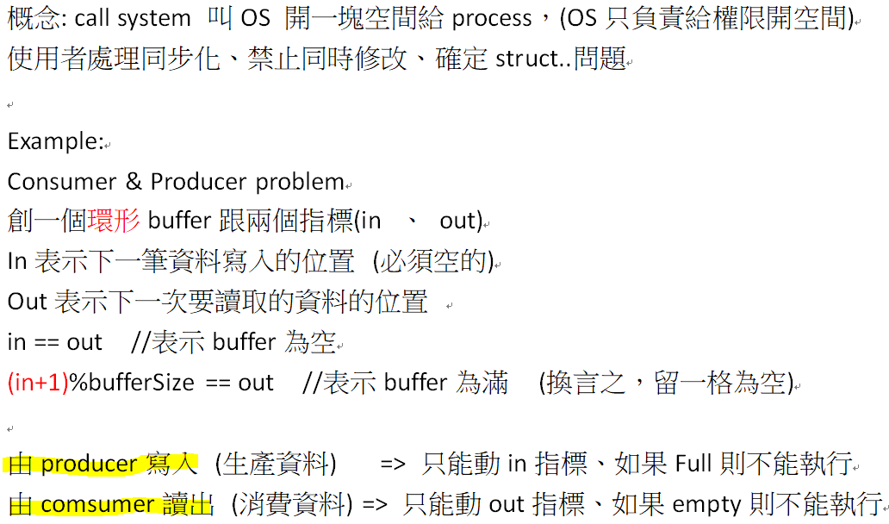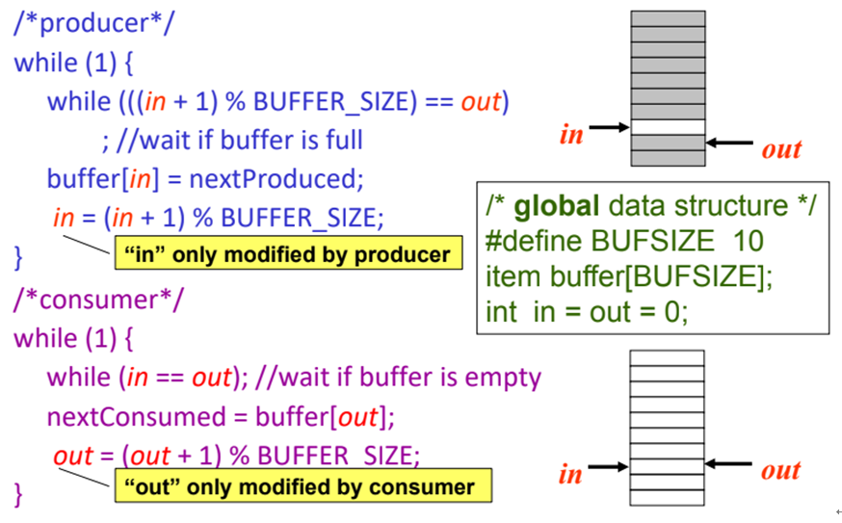

Producer:

oflag

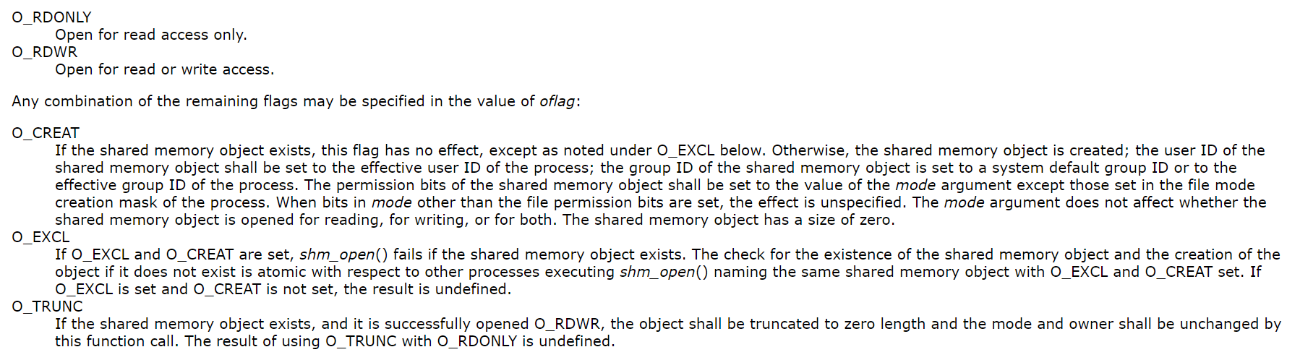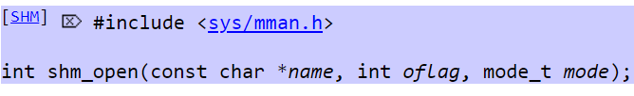

mode_t 就是權限 (類似700那個)